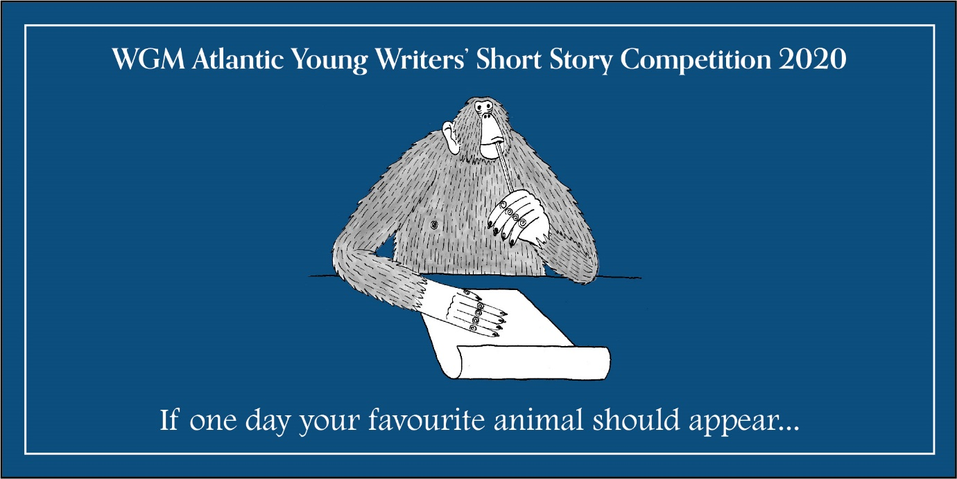
WGM Atlantic Literary Agency: Young Writers’ Short Story Competition 2020
(Illustration credit: Ehren Barnard)
The Competition
WGM Young Writers’ Short Story competition aims to encourage creativity and imagination.
It is open to young people aged between 5 and 12.
The award is run by WGM Atlantic Group. We believe that one of the keys to becoming a great author is to write when you are young.
More information about the competition can be found at: https://www.wgmtalent.com/blog-articles/wgm-childrens-writing-competition/

Prize:
The two winners will receive £75 each and the chance to work on their writing skills with an agent.

How to enter?
The 2020 WGM Atlantic short story competition is now open!
When you are ready to submit your writing please ask an adult to email your story (as a Microsoft Word or Pages document) to greg@wgmatlanticgroup.com, along with:
- Age of entrant
- Contact details to be used to notify the winner
Unfortunately, we cannot accept entries by post.
There are no fees.
Closing Date:
The deadline for entries is 9 AM on 20th June, 2020
The two winners will be announced on social media and through email on 15th July, 2020

Theme: What to write about?
Your Favourite Animal!

If one day your favourite animal should appear…

Who Can Enter?

Category 1: Age 5-8
We are looking for a short story up to 500 words in length.

Category 2: Age 9-12
We would love to read a short story up to 750 words in length.

Judging Criteria:
The competition will be judged by literary agents from WGM Atlantic Group. As with all the writing we receive, we will be looking for use of:
- Originality
- Language
- Entertainment
- Imagination

Entries will not be judged on spelling or grammar. We simply want to see something that is fun to read!

Terms & Conditions
- The Promoter: WGM Atlantic Group, 5 Chancery Lane, Holborn, London WC2A 1LG
- Eligibility: Open to UK residents aged 5 to 12, excluding employees and their immediate families of the Promoter or anyone professionally connected with the prize.
- Entries: Only one entry per person.
- Offensive Content: Entries the Promoter considers dangerous, offensive, indecent or copyrighted will be disqualified.
- Winner Selection: The winners will be selected by literary agents from WGM Atlantic Group based on the criteria outlined in the description.
- Period: The competition will run until 9am on 20th June, 2020.
- Entrant Details: It is the responsibility of the entrant to provide correct details when entering the competition.
- Legal Guardians: Submission of the story signifies that the entrant’s legal guardian gives permission for inclusion in the competition.
- Legal Jurisdiction: The Promotion and these terms and conditions, and any disputes arising therefrom, shall be subject to English law and the exclusive jurisdiction of the English and Welsh Courts.
- Data Protection: Any personal information entrants share with the Promoter will be kept secure and only used in line with these terms and conditions unless the entrant has opted in to future marketing from the Promoter. By entering the Competition, the winners consent to give their name for the winners’ list.

