What I’m grateful for
Draw yourselves in the middle of the sun and then spend time putting in each of the sun’s rays all the things you are grateful for at the moment. This could be the people around you, or the things you are able to play with, do or even eat. It is really important to reflect on the positives rather than thinking about all the things we can’t have or do.
Examples
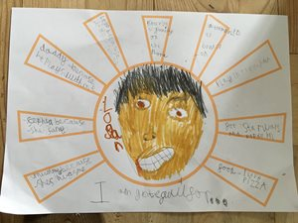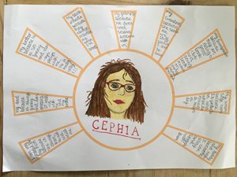

Gratitude tree
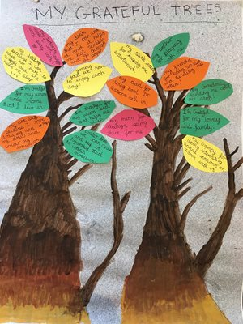
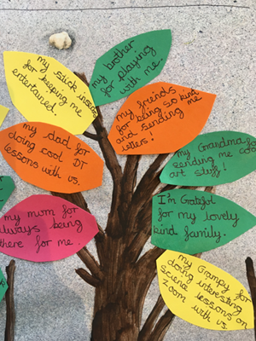
Either draw or paint the trunk and branches of the tree and then cut leaves out of different paper or card (if you have this available) or draw them on in different colours. Write on each leaf something or someone you are grateful for; make sure you give your reasoning behind why you chose that person or thing. You could add a leaf to your tree each day to remind you of all the positive things you do have, even during this difficult time.

It can be too easy to start thinking about all the things we can’t do or the people we can’t to see, but when you turn it around and think about the positive it has a really strong effect on how positive you feel and really helps us to feel happy.

